HISTOGRAM - CUSTOMER AGE DISTRIBUTION
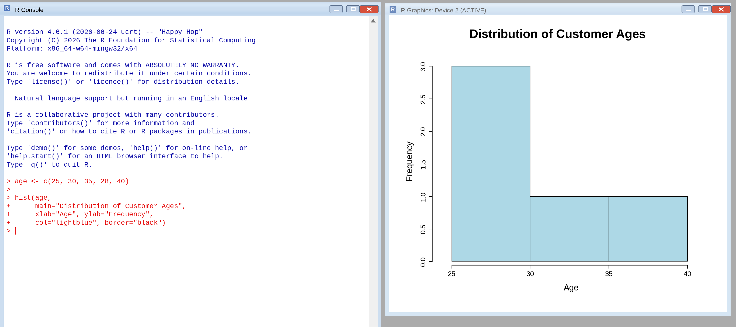
PIE CHART - CUSTOMER SATISFACTION SCORES
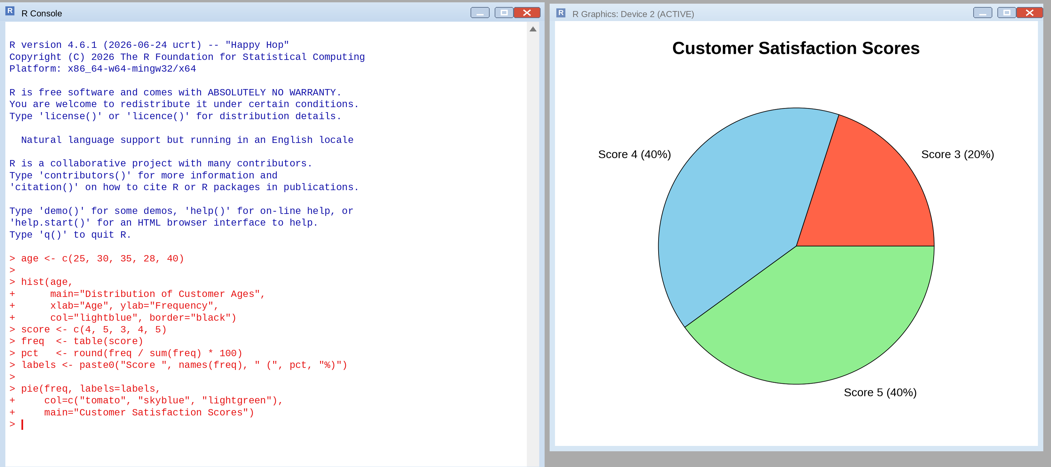
STACKED BAR CHART - SATISFACTION SCORES BY AGE GROUP
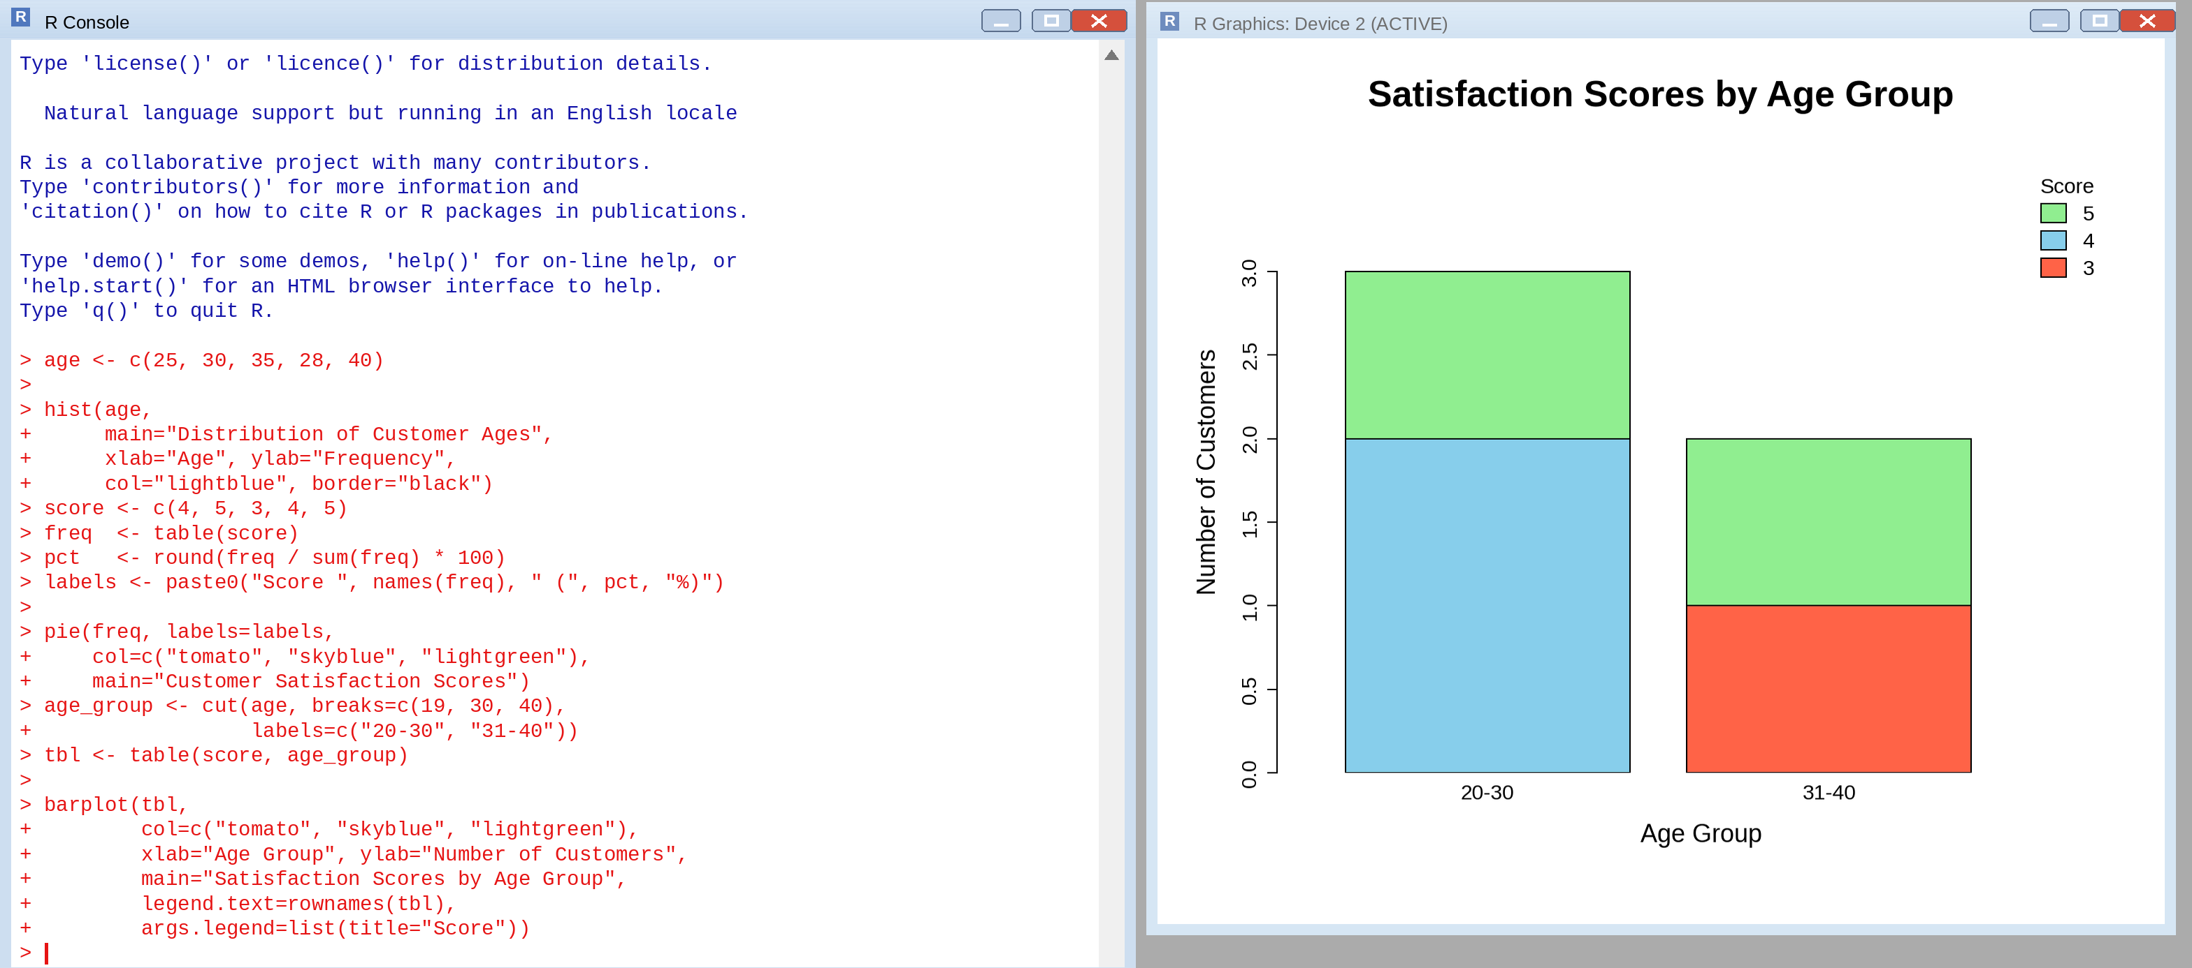
WORD CLOUD - CUSTOMER FEEDBACK
